**Azure_Billing_Detailed (Daily)**

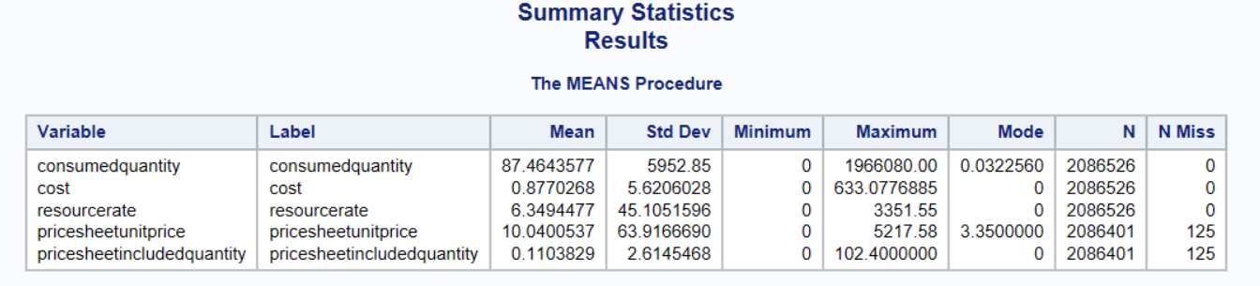

* costcenter - all values are 20560
* departmentname - AzureRD = ~70%
* manager_worker_no - top 3: 2786 (Cindy Taylor), 38650 (Mike Shelton), 1903 (Brad Chisholm).
* metercategory - top 3: storage, bandwidth, VMs
* meterregion - 42% missing
* resourceowner - 50% no resourceowner defined

**Azure_Billing_Detailed (Monthly)**

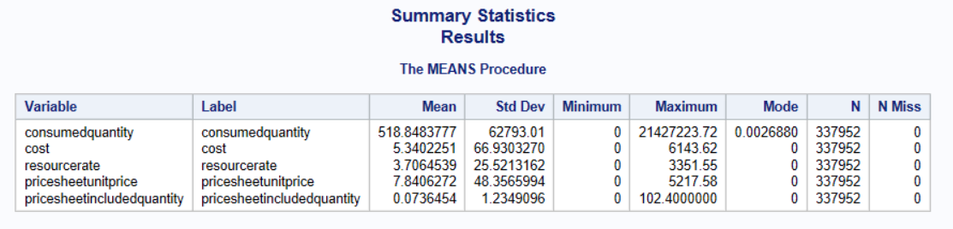

**Azure_Members**

* Accountname – only *azurecustsales* has member data
* Member – [azurecustsales@sas.com](mailto:azurecustsales@sas.com), [azurerd@sas.com](mailto:azurerd@sas.com), [azureit@sas.com](mailto:azureit@sas.com), 96706a82-8194-482d-9032-3bc31211 ???
* Membername & memberworkerno – 31% are not defined
* Role – 52% contributor and 43% owner

**Azure_RI_recommedations**

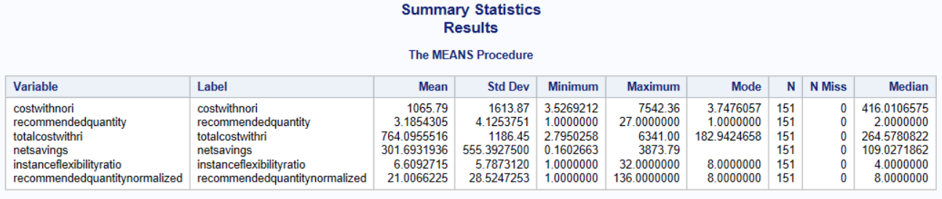

*More info on RI recommendation:*

<https://azure.microsoft.com/en-us/blog/get-usage-based-reserved-instance-recommendations/#:~:text=If%20you%20have%20Virtual%20Machines,optimum%20configurations%20of%20Reserved%20Instances.>

<https://docs.microsoft.com/en-us/rest/api/billing/enterprise/billing-enterprise-api-reserved-instance-recommendation>

**Cloud_Summary_Monthly**

Members – 94% missing

Region – top 3: EastUS, EastUS2 and USEast?

ResourceOwner – 55% not defined